**A Clean Energy Vision for East Africa**

*Planning for Sustainability, Reducing Climate Risks and Increasing Energy Access*

By

Daniel M. Kammen, Veronica Jacome, and Nkiruka Avila

*Energy and Resources Group*

*Goldman School of Public Policy*

*Renewable and Appropriate Energy Laboratory*

*University of California, Berkeley USA*

March 2015

**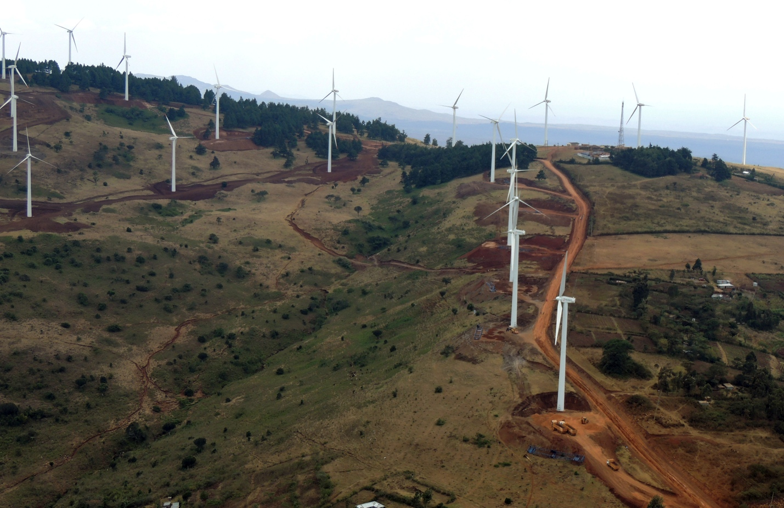**

****

Published jointly with Renewable Energy and Appropriate Energy Lab (RAEL: <http://rael.berkeley.edu/>) and International Rivers (<http://www.internationalrivers.org/>). Contact the authors at [kammen@berkeley.edu](mailto:kammen@berkeley.edu) | <http://rael.berkeley.edu>

**Please cite this article as: *A Clean Energy Vision for East Africa:* *Planning for Sustainability, Reducing Climate Risks and Increasing Energy Access (2015):***

[https://rael.berkeley.edu/?publications=a-clean-energy-vision-of-the-east-african-power-pool](https://rael.berkeley.edu/?publications=a-clean-energy-vision-of-the-east-african-power-pool" \o "This external link will open in a new window" \t "_blank)

This is an open-access article distributed under the terms of the Creative Commons Attribution-Non-Commercial/Non-Derivative Works License, which permits non-commercial use, distribution, and reproduction in any medium, provided the original author and source are credited.

**Executive Summary**

East Africa is now the fastest-growing economic zone in sub-Saharan Africa, and among the fastest economically growing regions in the world. The U.S. Department of Commerce (2010) and the McKinsey Global Institute (2012) both predict that the region may experience economic growth of 5-7% per year. This dramatic growth will place new obstacles on a region already facing problems with infrastructure challenges. The growing demand for energy, as well as new fossil fuel and renewable energy discoveries in East Africa, document the critical moment that exists today to chart a course of sustainable, or unsustainable regional growth and resource management. In this report, we examine the mix of energy resources currently in use, and discuss energy resources that are available to supply energy in the region.

We also review the energy planning being done by the East African Power Pool (EAPP), and make recommendations for its improvement. The EAPP is particularly important because it will likely both drive investment, and shape on-grid and off-grid investments in the region for years to come. At the same time, it is a critically important tool through which sound regional planning for energy resources, risks, and climate and demand impacts that are vital to the future of development in the region could take place.

We find that the clean energy potential of the East African region is sufficient to develop a strong economic, social and environmentally beneficial development plan that can exceed regional energy needs, make more significant progress in increasing energy access, and do so in a way that achieves environmental sustainability and contributes to a significantly more diverse and vibrant private sector. This “green growth” model will not be accomplished without significant coordination and cooperation in the management of the energy generation, transmission, and distribution investments, for both on-grid and, critically, off-grid energy solutions (Alstone, Gershenson, and Kammen, 2015).

We also look at the critical issue of climate risks. This report is consistent with, and extends a growing body of research that finds that climate change will dramatically impact the power sector. Forecast for the loss of hydropower capacity on some river systems may be as great as a reduction by *one half* of the total effective annual production from some of the most impacted river systems by mid-century. These early forecasts are often widely divergent, and controversial. While in some cases a number of relatively well-established tools are available (e.g., energy systems studies, crop modeling, hydrological and flood analysis, etc.), much more work is necessary to adequately address other types of effects, such as impacts on energy infrastructure and electricity production, human health, local and global environmental change, and the provision of ecosystem services.

**Framing Questions: Energy Options and Sustainability in East Africa**

To what extent can secure renewable energy resources play a dominant role in the energy situation in East Africa? To what extent doesWhat levels of regional cooperation and coordination to build on-grid energy systems promote economic development, political security, climate resilience and energy access in East Africa? Based on specific technologies and regional modeling efforts summarized in this report, we examine the expansion plans of the EAPP Master Plan and assess the potential benefits and risks of different energy supply and management options. The EAPP is particularly important because it will likely both drive investment, and shape the on-grid and off-grid investments in the region for years to come. At the same time, it is a critically important tool through which sound regional planning around energy resources, risks, and both climate and demand impacts that are vital to the future of development in the region.

**A Vision and the Reality of Clean Energy Growth: Kenya as the Emerging Clean Energy Leader**

As we examine the energy options in East Africa, proponents of virtually any growth plan can point to significant challenges and opportunities. The forecast for growth in wealth and in demand are tremendous, rivaling what has taken place in Asia; with ‘African Lions’ poised to rival ‘Asian Tigers’. Discoveries of oil, coal, and uranium are now widespread, and foreign investment in the region has never been higher in the modern era. At the same time, East Africa has not only some of the best solar, wind, biomass, and geothermal resources in the world, but also largely manageable urban areas and, with a few exceptions, low population density. This abundance of clean energy resources and a growing demand for both on-grid, mini-grid, and stand-alone energy services calls for a new integrated planning perspective.

Kenya provides an ideal test-bed. A nation with a current annual GSP growth rate of over 5%, rivaling anywhere in the world, Kenya is also a classically bifurcated sub-Saharan African state, with visions of 5,000 MW of new on-grid capacity in only 40 months, *and yet a population that is only 29% grid-connected today.*

In fact, a closer look reveals the tremendous advantages of a clean energy growth plan for the nation. Figure 1 illustrates the decoupling of energy generation and distribution assets, and a power mix that reflects tremendous energy resources. More than simply having a tremendous endowment of hydropower and geothermal energy that has been accessed in past decades, Kenya has examined the resource base and is now building a power mix that, if accelerated, will position the nation to have minimal, if any, need for imported fuels, and will enable the nation to claim a major leadership place in the coming clean energy economy.

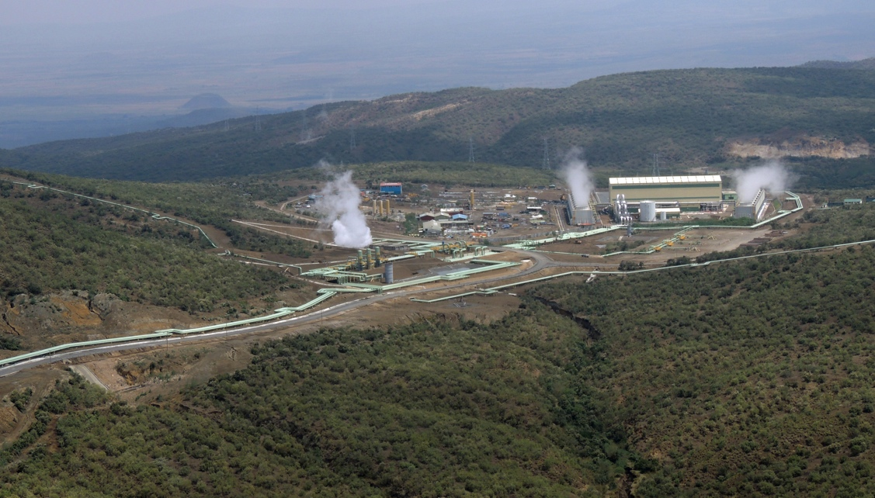Not only is the power demand growing, but climate change and increasing agricultural, household, and industrial demands for water mean that Kenya must meet this greatly increased demand while reducing dramatically its reliance on hydropower. The fact that Kenya has economically assessed geothermal resources alone that could meet a baseload demand of *10,000 MW* (KenGen, 2014), or more than five times national on-grid power demand today, means that even if a simple 1:1 replacement of hydropower with geothermal was needed, this would be possible. Figure 2 reflects this transition, and the wealth of resources that Kenya has to enable this transition.

Photo: 1 Olkaria Geothermal Plant, Kenya. By Dan Kammen

**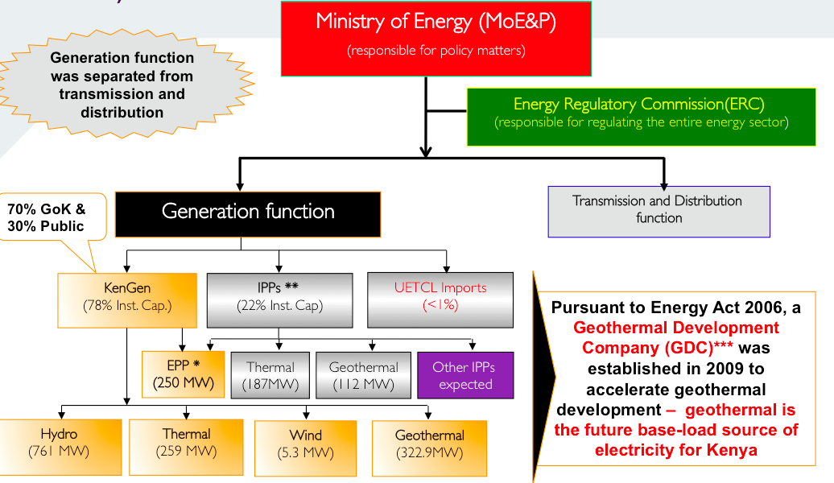**

**Figure 1:** *The reform process in Kenya showing both the evolution of the power sector into regulated generation and transmission components, and a power mix that reflects tremendous renewable energy resources.*

In fact, Kenya is on pace to expand the geothermal production at the Olkaria site in Hell’s Gate National park from just over 500 MW to over 3,000 MW in just a few years. This transition has liberated planning decision-making and international investment that will make this process, if properly managed, achievable and profitable. Geothermal is today *the least-cost form of on-grid generation in Kenya, with costs as low at 8.5 cents/*kWh, *one third of the fossil fuel costs.* The Olkaria complex, with six generators online or coming online shortly, reflects another new reality: Kenya is enabling both national generation company (KenGen) *and private sector* investment and installations so that an entrepreneurial environment is now not only possible, but a reality.

The geothermal story in Kenya is not unique. After a decade of experimentation and learning with the Ngong Hills Wind Farm (new farms coming online at Isiolo, Machakos, and soon-to-be Africa’s largest wind farm at Lake Turkana, which we visited in August 2014) are not only heralding in a phase where wind could rival geothermal as a growth industry, but one where new discoveries (such as the incredibly rich wind resource along the eastern edge of Lake Turkana) suggest that what is taking place in Kenya could also happen elsewhere in the region.

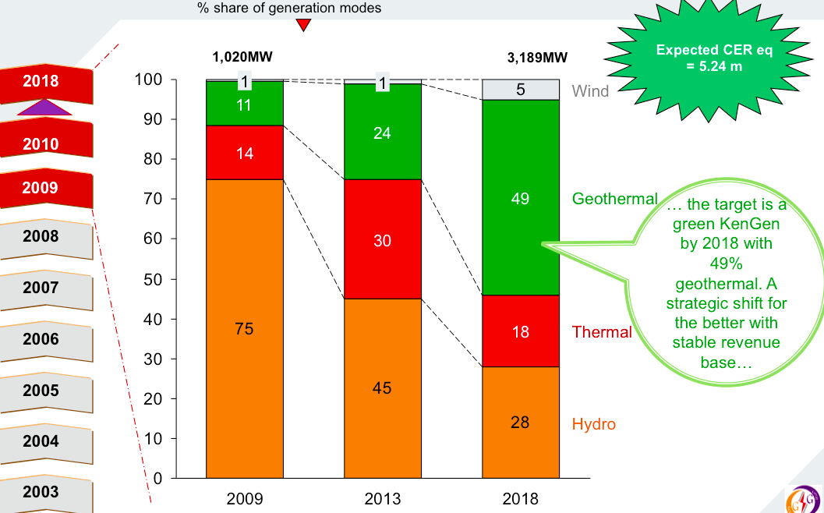

**Figure 2***: The needed and envisioned transition from a hydropower dominated to a geothermal dominated energy sector for Kenya.*

This energy expansion plan for Kenya illustrates East Africa’s high potential for a clean-energy future. Not only can Kenya now realistically plan to achieve generation levels of over 33 GW of capacity (and peak demands of ~ 25 GW) in 2030, but can do so with a power mix forecast to be more than 75% carbon free.

Challenges do remain, with the off-grid population and the expansion of programs that bring energy services to the poor a second key issue (but where efforts like Beyond the Grid, and the growing private sector pay-as-you-go programs of M-KOPA, SunnyMoney and others are making progress). We address these opportunities in other reports (Schnitzer and Kammen, et al., 2014; Casillas and Kammen, 2010, 2012).

At the industrial level, however, the expansion of clean, on-grid energy can also bring about a new industrial potential. Even while taking the prudent step to dramatically reduce the planned use of hydropower, Kenya is planning a new industrial corridor built around clean geothermal, wind, and solar energy (Figure 3).

**Figure 3:** *A clean energy corridor vision for Kenya, Ethiopia and Tanzania based around renewable energy*

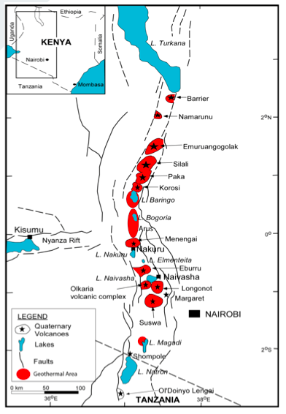This new, integrated energy picture is one that drives the assessments in this report. The findings that clean energy can dominate the energy mix in East Africa stands out. So, too, do the remaining challenges, of off-grid energy access, and a transition to a clean transportation system (such with the growth of electric vehicles and the use of sustainable biofuels – e.g., those that do not compete directly with food supply – if possible).

**A New Regional Framework: The East Africa Power Pool**

The East Africa Power Pool (EAPP) was established in 2005 by the Inter-Governmental Memorandum of Understanding (IGMOU) consisting of seven countries: Burundi, Democratic Republic of Congo (DRC), Egypt, Ethiopia, Kenya, Rwanda and Sudan. Tanzania, Libya and Uganda joined the power pool a few years later, bringing the total to ten countries. Its member utilities are REGIDESO (Burundi), SNEL (DR Congo), KenGen and KPLC (Kenya), EEHC (Egypt), EEPCO (Ethiopia), GECOL (Libya), NEC (Sudan), Tanesco (Tanzania), EWSA (Rwanda), and SINELAC (DR Congo- Rwanda - Burundi). The EAPP released its Master Plan in 2011 and an updated plan in 2014 (EAPP, 2013).

The EAPP has been adopted as a specialized institution for energy by the Common Market for Eastern and Southern Africa (COMESA). The mission of the EAPP is to facilitate and secure power to its countries at the least cost possible. The pool is based on a regional least-cost standard intended to benefit all its countries. The EAPP plans to achieve this through the pooling of the countries’ energy resources to satisfy increasing electricity demand. Also, the EAPP plans to establish a regional electricity market by coordinating a power exchange among its countries’ power utilities. The EAPP is still in developmental stages; the projected date for the regional electricity market is set to begin in 2017 (Kambanda, 2013). The EAPP has received funding from several sources including the World Bank, the African Development Bank (AFDB) and the United States Agency for International Development (USAID).

The following table shows the major players involved in the EAPP Master Plan and the activities being financed.[[1]](#footnote-1) The World Bank is currently shown to be the largest supporter with a total of 1.044 billion US$ committed to activities directly associated with the EAPP Master Plan. The World Bank is supporting both the Ethiopia-Kenya Interconnector (construction expected to begin in late 2015), and the Rusumo Falls Project. According to the EAPP Master Plan Executive Summary (2011a), the lines connected to the Rusumo will connect the project with Tanzania, Burundi, and Rwanda (p ES-2).

|  |  |  |
| --- | --- | --- |
| **Financing Agency** | **Activity** | **Amount** |
| European Commission | Technical Assistance and Capacity Building | $3.7 million |
| African Development Bank | Master Plan and Grid Code Study | $1.7 million in financing |
| USAID/UNDESA | Bilateral and Transmission Wheeling Agreements: Negotiations and Adoption | $2.4 million |
| The World Bank | East Africa Power Pool - Ethiopia-Kenya Interconnector | >$1.0 billion[[2]](#footnote-2) |
| Rusumo Falls Hydroelectric and Multipurpose project |
| The Royal Norwegian Ministry of Foreign Affairs | Coordination and Dispatch Centre Infrastructure | $2.2 million |

**Table 1:** *Major funders and activities of the EAPP Master Plan**. All figures in 2014US$.*

**EAPP Status Report: Accomplishments and Challenges**

Approximately 77% of the EAPP’s existing installed power capacity comes from thermal sources with hydropower comprising about 22% of the total power capacity.[[3]](#footnote-3) The hydro share is expected to grow due to current and future investments in hydropower projects in the region such as Ethiopia’s Gibe III, which has a nameplate capacity of 1,870 MW. An article by the International Consortium for Africa (ICA) reports that by 2020, the EAPP’s power generation mix will have an increasing share of hydropower (2011). This prediction presents economic and climate risks associated with over-dependence on hydropower. These risks are discussed in detail later in this paper.

The power generation and consumption profiles for a majority of the members in the EAPP are shown in Figure 4. The data are compiled from 2008, which was the baseline for the current Master Plan. Not shown in Figure 4 is Egypt’s generation and consumption, which dominates the EAPP’s total with approximately 128,000 GWh of generation and roughly 107,000 GWh of consumption 2008 (ICA, 2011). This situation, based on pre-existing generation provides one view of the installed energy basis for the region, but does not reflect the dramatic changes that are underway, and that are possible in the future. Kenya’s ambitious plan for over 5,000 MW of energy capacity in 40 months reflects the scope of the new energy economy proposed in the region (Ministry of Energy and Petroleum, 2014)[[4]](#footnote-4).

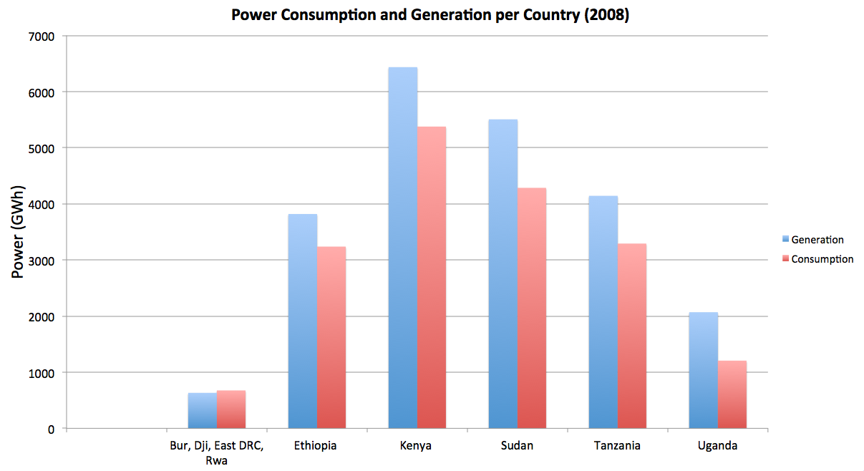**Figure 4:** *EAPP region electricity consumption and generation for 2008[[5]](#footnote-5)*.

Although one of the main goals of the EAPP is to facilitate a power trade among the countries, that process is today at an early stage, largely due to the time it takes to build transmission capacity. As of 2008, the most recent EAPP-wide data available, the EAPP only traded 0.4% of its electricity (ICA, 2011). The EAPP plans to increase its regional power trade using the upcoming Ethiopia-Djibouti and Kenya-Ethiopia interconnections (this latter has been controversial due to its association, disputed by the World Bank, with the Gibe III Dam being built by Ethiopia). To achieve efficient power trade, Kenya will need to establish more extensive power market institutions. Burundi is interconnected with Rwanda and the DRC through a hydropower station Ruzizi II operated by SINELAC. Burundi is also interconnected with DRC through the 70 kV line to the Mururu substation belonging to DRC, and with Rwanda through the 110 kV line to Mururu II substation belonging to Rwanda (ICA, 2011). The largest power exporter is Egypt with current interconnections to Libya and Jordan, and its interconnections to Djibouti, Sudan and Kenya are under construction or still being approved (ICA, 2011).

**EAPP Energy Resources**

Currently, the EAPP’s electricity mix consists of coal, oil, hydropower, geothermal, natural gas and other renewable sources. As seen in Figure 5, Ethiopia contributes the majority of the EAPP’s hydropower. Kenya has substantial wind energy potential and plans to build the largest wind farm in Africa (IRENA, 2013a). Furthermore, Ethiopia, Kenya, and Tanzania combined have identiﬁed about 15 GW of cost-effective geothermal (2013a.)

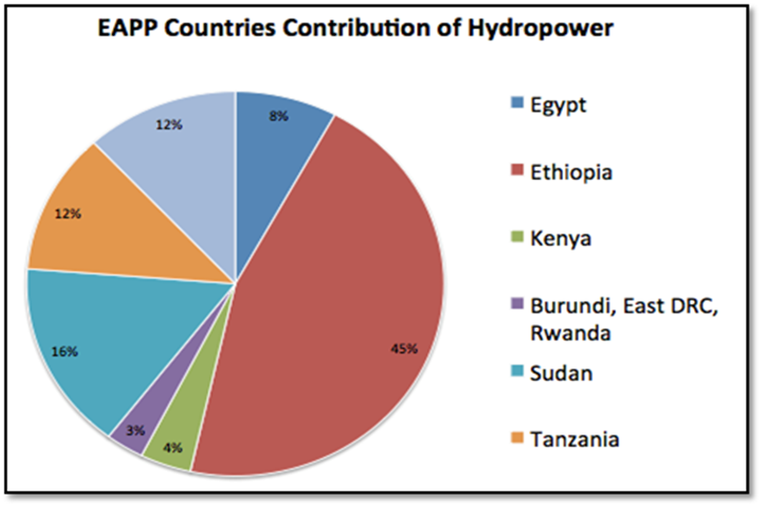

**Figure 5:** *Ethiopia currently generates about 45% of the 32000 MW total hydropower generation capacity of the EAPP* *(IRENA, 2013).*

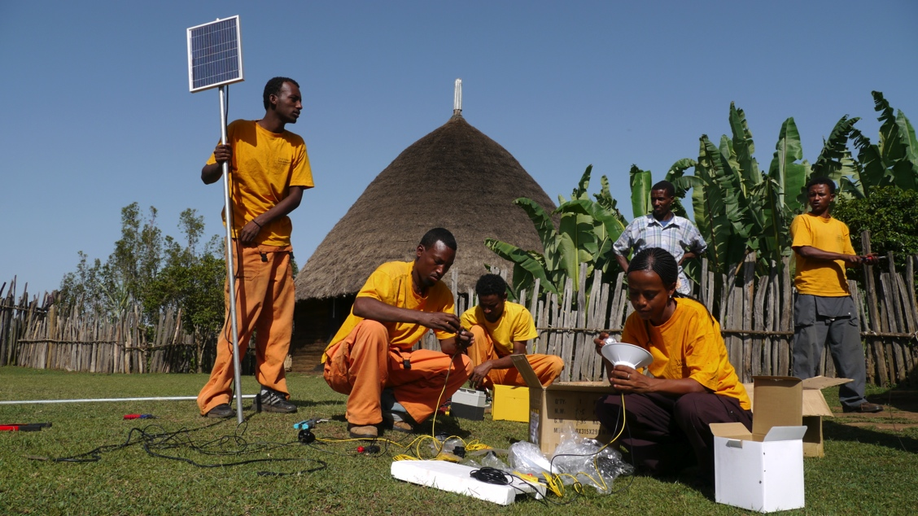Furthermore, East Africa has abundant non-hydro renewable energy potential, with applicability for use in regional grid systems and off-grid rural areas. There are ample solar energy resources with average solar radiation ranging from 4 kWh/m2 to 8.0 kWh/m­2 per day (Karekezi et al, 2006). In Ethiopia, the average solar radiation is 5.2 kWh/m2 per day and less than 1 percent of this renewable resource has been exploited (Power et al, 2009; Derbew, 2013). A market analysis completed by the Deutsche Gesellschaft für Technische Zusammenarbeit (GTZ) as part of the Project Development Programme (PDP) East Africa has identified 52 MW of solar PV off-grid market potential in Ethiopia alone (Power et al, 2009). Table 2 highlights some non-hydro renewable resources potential identified in Ethiopia, Uganda, Kenya, and Tanzania.

Photo: 2 Solar Energy Foundation installs solar in Ethiopia. Photo: SEF

|  |  |  |  |  |
| --- | --- | --- | --- | --- |
|  | **Biomass** | **Solar** | **Wind** | **Geothermal** |
| **Ethiopia** | 32 MW | ~5.2 kWh/m2/day  PV off-grid: 52 MW | 10,000 MW | 700 - 3,000 MW |
| **Uganda** | 48 MW | 5-6 kWh/m2/day  PV off-grid: 70 MW | Some Potential | 450 MW |
| **Kenya** | 159 MW | ~5 kWh/m2/day  PV off-grid: 40 MW | ~3,000 MW | 10,000 MW |
| **Tanzania** | 102 MW | ~5 kWh/m2/day  PV off-grid: 35 MW | Short-term  300-500 MW | 600 MW |

**Table 2:** *Non-hydro renewable resource potential identified for Ethiopia, Uganda, Kenya, and Tanzania.[[6]](#footnote-6),[[7]](#footnote-7)*

Other potential areas for capacity expansion include energy from municipal solid-waste. For example, 10 MW of potential capacity from solid-waste has been identified in Rwanda (EPD, 2013), while Kenya has an estimated potential of about 200MW from its sugar industry alone. This resource is particularly important because it can serve the low-carbon energy system in several ways. First, biomass can be a zero carbon – or close to net zero – resource *if* the biomass is used and sustainably re-grown (Sanchez, *et al*., 2015). Second, it provides storage capacity, which when combined with geothermal and hydropower provide baseload and dispatchable clean energy for Kenya, and in fact most all nations in the East African region who are endowed with exceptionally large and cost effective geothermal and biomass energy resources.

**Addressing Energy Poverty and Electricity Access**

The provision of affordable modern energy services is critical to overcoming poverty and socio-economic development. In the East African community energy consumption per capita is less than 1000 kWh for every country excluding Egypt (ICA, 2011). Additionally, the International Energy Agency’s (IEA) 2012 World Energy Outlook placed Ethiopia at the lowest rank (out of 80 countries) with respect to the Energy Development Index (EDI), followed closely by Rwanda (78th), Uganda (76th), Tanzania (69th), and Kenya (68th).[[8]](#footnote-8) Not surprisingly five percent of Ethiopia’s rural population has access to electricity compared to 85% of its urban population (Tessama, 2013). In other words, roughly 69 million people lack access to electricity in Ethiopia (WEO, 2010). In spite of these alarming figures, the EAPP’s Master Plan does not specifically provide detailed plans for alleviating energy poverty in rural communities. At the same time, Ethiopia is increasing its electricity exports from hundreds of megawatts as of 2014, to over 2,000 MW by 2018 (U.S. Department of State, 2013; Macpherson, January 16, 2015; EAPP, 2011b). In spite of these alarming figures, the EAPP’s Master Plan does not specifically provide detailed plans for alleviating energy poverty in rural communities.

Ethiopia has plans to address this situation. The Ethiopian Growth and Transformation Plan focuses on harnessing the country’s energy potential, mainly through large-scale dams but also with renewables such as wind, geothermal and biofuels (Seo and Mendelsohn, 2006; Block and Strzepek, 2010). Its advancement of rural electrification has seen some progress in the past few years and its energy development index (EDI) has improved by 30% since 2002 (World Energy Outlook, 2012). Also, high-voltage transmission lines increased across the country by 33% in three years by 2012 (ICA, 2011). More efforts are required to achieve equitable energy access throughout the country.

Kenya is also making progress in meeting rural electrification through both government and private sector efforts. The 2012 Kenyan National Energy Policy describes efforts to address energy access issues with the proposed interconnections with Ethiopia, Tanzania and the Southern African Power Pool. Also in the Energy Policy, Kenya has outlined a distribution system expansion plan with the goal of increasing interconnectivity from 22% to 30% by the end of 2014, and by connecting one million customers in five years starting in 2009 (Republic of Kenya Ministry of Energy, 2012). The Kenyan Rural Electricity Authority (REA) has medium term goals to expand rural electrification by 50% from 2012 to 2022 using both grid extension and off-grid strategies. According to the REA, over 12,000 facilities (including trading centers, public schools and health centers) have been electrified since 2003. REA has also implemented initiatives to promote off-grid electricity by publishing solar water heating regulations, formulating a framework to promote solar, wind and biogas generation, commercializing solar energy generation, and implementing net metering policies for solar generation in buildings (Republic of Kenya Ministry of Energy, 2012).

The private sector is proving to be of growing importance with increasing energy access. For example, off-grid solar companies SunnyMoney and M-KOPA Solar are information technology and mobile banking programs that support off-grid solar expansion.[[9]](#footnote-9) In each of these efforts, personal and household off-grid lighting and other energy products are available on a fee basis for either lease to own (M-KOPA Solar) or purchase (M-KOPA Solar and SunnyMoney; Alstone, Gershenson and Kammen, 2015) programs, and are reaching significant numbers of users. To date, several hundred thousand accounts and purchases have been registered in Kenya alone.

The traditional approach to increasing energy access by simply focusing efforts to expand the electricity grid and investing in large, centralized projects does not address energy poverty and access. A study done by Oona Nanka-Bruce (2010) with the University of Surrey, UK, has shown that successful energy access scenarios requires a combination of institutional, economic, social and technical considerations. The results conclude that “the Human Development Index, wealth distribution, the level of institutional development and the size of the urban population” all play a significant role for impacting rural electrification (we detail this is Alstone, Gershenson and Kammen, 2015). Connecting to the grid does not simply imply that households will have sufficient resources to support electricity consumption. East Africa should focus its efforts in a holistic manner, assuring that all factors are considered. Successful energy development requires both bottom-up and top-down approaches, and the EAPP should be revisited to ensure this bottom-up approach is given co-equal and widespread official support and attention it needs to thrive, and is not set back by EAPP’s top-down program. Kenya has been a leader in recognizing this approach, but more can be done to disseminate this to northern districts and communities, and to look at the co-benefits of energy access for economic productivity and social inclusion of minority communities.

The EAPP goal is to provide electricity at least-cost to the region with the ultimate goal of meeting the region’s growing demands and setting up a regional electricity market. To complement the efforts of the EAPP, the East African Community (EAC) approved the Regional Strategy for Scaling up Energy Access to Modern Energy Services in 2006. The goal of this was to identify and map the energy needs of half the EAPP countries’ populations by 2015 and provide at least half of its population with access to modern energy services. This effort requires an additional $3.4 billion investment. A recent review of this EAC strategy by a Norwegian Consultancy NORPLAN states that these goals will not be accomplished by 2015 (NORPLAN, 2013). This failure can be ascribed to several reasons. Firstly, the EAC’s mandate has no effective authority to influence the implementation of the regional strategy. This is because the strategy was developed by the EAC but the responsibility of implementation was assigned to the partner states of the EAC. Because no roadmap was designed on how to achieve each target, there is much confusion between the partner states on how to proceed. Secondly, the regional strategy states ambitious goals that are beyond the resource capacity of the partner states. There is a dire need for private investment to supplement the limited funding of the partner states in order to supply affordable and modern energy services to the population. The potential for private investment is significant; the EUEI estimates that with the exclusion of the top 20% income households, poor households spend about $1.2 billion on energy services. However, a key challenge to rural electrification is expensive connection costs. The alternative solutions must be designed to be inexpensive, easy to use and sustainable.

**Recommendations**

*We recommend that the EAPP take steps to ensure a balance is maintained between the push for more on-grid power and the need – which drives social equity and economic growth most rapidly in marginalized communities – of increasing energy. Pay-as-you-go solar, community mini-grids have proven to be very fast to deploy and very effective means of providing the first units of electricity. We therefore recommend that the EAPP itself give a high priority to meeting demand through the region’s solar PV off-grid market potential, especially in Ethiopia, South Sudan, and in conflict regions generally, where local, autonomous solar, builds local resiliency. Additionally, EAPP should analyze the various players involved in rural electrification projects across the region in order to establish a plan that incorporates the current and future projects that are already under consideration. This would avoid redundancies and competing efforts and provide a network that will advance electrification in the most efficient way possible.*

**Demand Projections and Assumptions**

According to IRENA (2009), Africa’s population is estimated to double by 2050 and its energy needs will grow even faster. According to the United Nations Population Fund, the fertility rates in East African countries are high, ranging from 4.6 to 6.7 children per woman for countries such as Uganda, Burundi, Tanzania, and Rwanda (Emorut, 2012). Similarly, the World Population Prospects projects Uganda, Tanzania, and Burundi populations to increase at least five-fold by 2100 (WPP, 2012). Furthermore, Ethiopia’s population is expected to nearly double from 94 million in 2013 to 188 million in 2050 (WPP, 2012, p.5). This growth in population reflects a report by the International Renewable Agency that states full electricity access in Africa will require its current total electricity generation to double by 2030 (IRENA, 2009).

The Master Plan highlights the EAPP’s demand and supply projections and uses the Model for Analysis of Energy Demand (MAED) to generate these demand forecasts (EAPP, 2011b). MAED is an end-use forecast model designed by the International Atomic Energy Agency (IAEA). Kenya’s Ministry of Energy assumption for its demand projection is that “all critical drivers for electricity consumption will perform well moving forward” (EAPP, 2011c, p. 172). This assumption was the basis of three GDP growth scenarios (low, reference and high) developed in the MAED model for Kenya. The average GDP growth rates in the 2008-2030 periods are 7.1, 8.6 and 9.8 percent for the low, reference and high scenarios respectively. These growth projections are consistent with the EIA, which lists a 2012 demand growth rate of 7% for Kenya. Furthermore, IRENA reports that electricity demand in Kenya, Ethiopia and Tanzania grew about 7% over a five-year period from 2005-2010 (IRENA, 2009). If this growth rate continues, the region’s electricity needs will quadruple by 2030 (IRENA, 2013).

In Kenya, the low-growth case is based on the assumption that the Kenyan economy will continue to be negatively impacted by destabilizing factors such as the ongoing impacts of the recent global economic recession, volatile energy costs and poor infrastructure. The reference case is based on the assumption that the economy will progressively grow at a rate of about 10% per year by 2013. It is also based on the assumption that there is significant investment in physical infrastructures such as energy and roads and public works. The high case is based on the premise that the Kenyan Government will address all the destabilizing factors to spur growth beyond Kenya’s Vision 2030 goals.

For Ethiopia’s demand forecast, the EAPP Master Plan reviewed the Ethiopian Electric Power Corporation’s (EEPCO) existing national forecast, as well as produced scenarios of their own (EAPP, 2011c). The Master Plan reviewed the Moderate I demand forecast scenario created by EEPCO with an assumed GDP growth of 8% per annum (2011c).[[10]](#footnote-10) However, the EAPP Master Plan found “the resulting demand forecast scenarios developed by EEPCO to be high” (E-11) and subsequently produced their own demand forecasts using the Regression Analysis Load Forecast (RALF) model. These demand forecasts, take into consideration historical data on population, GDP, consumer sales, electricity generation and peak, as well as forecasts of population and GDP (E-14, E-15). The GDP forecast for the PB scenarios is shown in Figure 6.

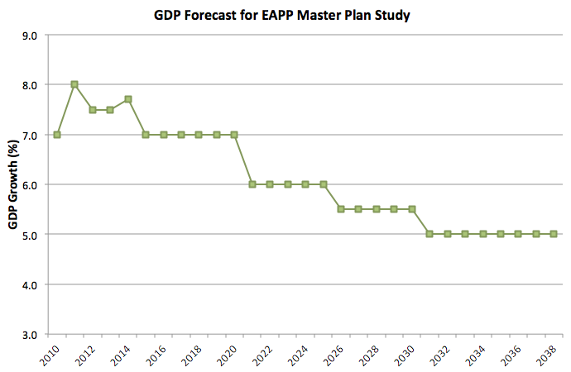

**Figure 6:** *GDP forecast for the EAPP Master Plan’s PB base scenario (E-18).*

The Master Plan considered the GDP forecast in EEPCO’s Moderate I demand to be high and a challenge to achieve, therefore, it adopted the International Monetary Fund’s (IMF) GDP forecast for the years 2010-2014 with an average of 7% growth per annum (E-17).[[11]](#footnote-11) The PB demand forecasts are shown in Figure 7, comparing the PB low case, base case and high case with the EEPCO Moderate I forecast. The high and low cases represent high and low GDP and population forecasts.



**Figure 7:** *PB demand forecasts for interconnected system compared with EEPCO Moderate I forecast (E-27).*

However, the Ethiopian modified national generation expansion plan in the EAPP Master plan (shown in Figure 8) shows an expansion plan based on the demand forecast generated by EEPCO’s Moderate I scenario. The load around 2038 in Figure 8 is approximately 16,000 MW, the same as the forecast for 2038 shown in Figure 7 under the Moderate I scenario. There is no mention of an expansion plan based on the PB demand forecast scenarios given a smaller GDP growth. Therefore, we recommend the EAPP Master Plan identify savings of extra capacity by using the PB scenarios identified in Appendix B of the Master Plan.

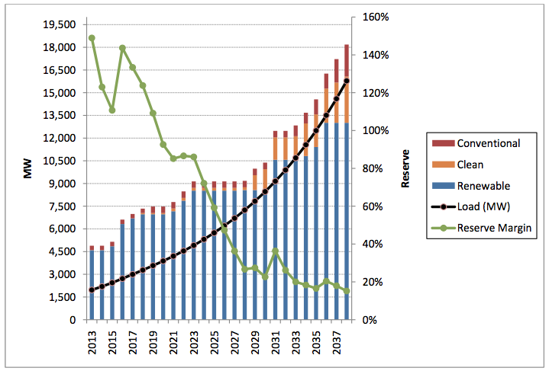

**Figure 8:** *Ethiopia’s Modified National Expansion Plant by Plant Category (EAPP, 2011b)[[12]](#footnote-12)*

**Potential of Energy Efficiency and Demand Side Management**

There is strong potential for energy efficiency actions in the East African community to reduce electricity demand, provide greater reliability, and reduce the need for dirty and expensive peaker power plants. Some nations have begun to address efficiency. For example, although Kenya’s electricity consumption increased by 27% from 2005–2010 (Republic of Kenya Ministry of Energy, 2012) and national energy wastage was initially high, Kenya has begun to take steps to reduce energy demand. Between 2001-06, a national energy efficiency project funded by GEF-UNDP saved the equivalent of a 140 MW power plant operating for a year.[[13]](#footnote-13) This is an area where partnerships with industrialized nations can be particularly valuable, as can efforts by multinational institutions to promote the design and sale of ‘super-efficient’ appliances. Because the poor spend a disproportionate amount of their income on energy, efficiency is a pro-poor policy. Programs include a regulation that requires all buildings with hot water capacity greater than 100 liters a day to install solar water heating systems (Republic of Kenya Ministry of Energy, 2012); and a regulation that requires facilities to perform energy audits and encourages the implementation of at least 50% of energy efficiency potential (Kenya 2012, p.7). Also, the Kenya Power and Lighting Company pledged to provide Kenyans with 3.3 million free CFL bulbs to promote energy efficiency (Kenya, 2012). This light bulb project alone was expected to save 130 MW nationwide. In Egypt, the government has pledged to take executive actions to reduce energy consumption by 8% through energy efficiency measures. Egypt has proposed a plan to implement energy efficiency to save 20% of its current electricity consumption by 2020. Egypt’s Ministry of Electricity and Energy has focused on efficient lighting and has deployed over 6.5 million CFL bulbs since 2009 to reduce electricity consumption.

There are also important energy efficiency initiatives like the UN-Energy Knowledge Network Energy Efficiency Initiative that are investigating the potential and implementation of energy efficiency measures in East Africa.‬‬‬‬‬‬‬‬‬‬‬‬‬‬‬ These efforts can both collect critically needed data on energy demand, but also highlight the most effective programs to supply needed power for residential and commercial activities. A program to push the World Bank, the African Development Bank, and national aid and development agencies to promote the sales of super-efficient appliances (as Lighting Africa and now Lighting Global have done) would be a huge step forward.

**Evaluating the Risks of Reliance on Hydropower**

The EAPP is expected to rely heavily on large hydropower dams. Currently, approximately 24% of the energy generated in EAPP countries comes from hydroelectricity, but future investments are focused largely on big dams, which will create a greater dependence on hydropower (ICA, 2011). The EAPP has identified hydropower projects that will add an installed capacity of roughly 24,000 MW by 2030 (EAPP, 2011). This additional hydropower will almost double the EAPP’s current installed capacity of 36,000 MW, and result in approximately 14,000 MW or 60% coming from Ethiopian hydropower generation alone (EAPP, 2011b). The region’s reliance on hydropower is shown in Figure 9 below, which highlights both current and future installed hydro capacity.

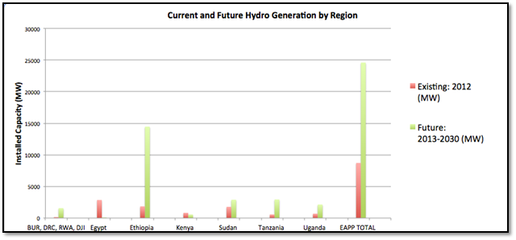

**Figure 9:** *Current and Future Hydropower Installed Capacity (EAPP, 2011b). BUR, DRC, RWA, DJI refers to Burundi, East Democratic Republic of Congo, Rwanda, and Djibouti.*

Non-hydropower renewable generation projects are under discussion within the EAPP, but most large-scale funding is focused on prioritizing the construction of large dams at this time. We recommend the EAPP prioritize the utilization of non-hydro renewable electricity sources, highlighted in Table 2. These sources account for approximately 20,000 MW of potential capacity- or roughly 80% of the identified hydropower projects in the EAPP Master Plan. Furthermore, we recommend the completion of additional studies by the EAPP to capture all small-scale, decentralized potential electricity sources in the entire East African region in order to avoid as many large-scale hydro projects as possible. The reason for this is simple: mini-grids and community energy programs can greatly build local energy access and economic opportunity, and can be the ‘seeds’ of growing regional grids. This decentralized energy policy builds economic growth across nations, which often overly focus their economic empowerment programs on the capital and large second-tier cities, not on rural communities that are so vital to the quality of life across East Africa.

While detailed project-by-project analysis is needed to assess the *economic* potential for diversification to non-hydropower renewable energy generation in the region, straightforward resource assessment for the EAPP member and observer nations is instructive. The solar resource alone is sufficient to provide the needed energy resources for each EAPP nation. This statement alone is neither surprising nor controversial at the *resource* level. Economically, two issues emerge: intermittency and cost. Recent cost declines in both solar thermal and solar photovoltaic generation (Zheng and Kammen, 2014) put solar energy in direct cost competitive status to all sources except hydropower. A key policy issue, however, are the tariffs and import fees, which in some nations can exceed 35% of FOB cost, in particular for solar photovoltaic equipment.

**Climate Risks of Hydropower**

The expansion of hydropower in Ethiopia poses major risks due to the hydrological effects of climate change. Ethiopia currently generates 99% of its electricity from hydropower (Davis et al., 2013), making it particularly vulnerable to changing precipitation patterns. Projections that Ethiopia could receive higher rainfall as a result of climate change have been discounted by Dr. Chris Funk, a climatologist with the U.S. Geological Survey (USGS) and researcher at the University of California, Santa Barbara. His research has determined that global warming has warmed the Indian Ocean and resulted in decreased rainfall in East Africa. The increased frequency of droughts in East Africa will continue as long as global temperature continues to rise.

An analysis of the climate trends in Ethiopia show that climate change has likely resulted in a 15-20% decline in rains since the mid-1970s.[[14]](#footnote-14) This has resulted in substantial warming and dryness across the country especially in the Rift Valley in South Central Ethiopia. These findings highlight significant risks that hydropower dependency brings to the regional and local electricity sector, as well as the broader economy. While added research is needed, a recent assessment finds that:

*Using four IPCC-vetted Global Circulation Models (GCMs) to bracket the uncertainty surrounding future climate outcomes, the paper finds that by 2050 climate change could cause GDP to be 8–10 percent smaller than under a no-climate change baseline; it could induce a two-fold increase in variability of growth in agriculture; and it would affect more severely the poor and certain parts of the country. The paper also finds that adaptation to climate change might cost an annual average of USD 0.8–2.8 billion; and an additional USD 0.4 to 3.0 billion if one takes into account residual damages which may not be addressed by adapting existing development plans (Robinson, et al., 2013).*

To avoid this risk, Ethiopia could take greater steps to diversifying its power mix. As an example, an analysis on the impact of climate change on hydropower schemes in the Blue Nile River shows clearly that, with the forecast for greater hydropower variability, the national energy system becomes increasingly fragile. Diversification into solar, and wind – as in Kenya – is a strategy for economic vitality and resilience. A study performed by the International Institute on Water Management shows that climate change will constrain the technical performance of large reservoirs with knock-on effects for agriculture and electricity production. (Mohamed and Loulseged, 2008). There have been a number of studies specific to Africa that reveal a high risk of poor performance from hydropower dams from the Volta to the Zambezi[[15]](#footnote-15). Too little information exists about the risks to hydropower dams in East Africa to justify such a heavy growth in hydropower.

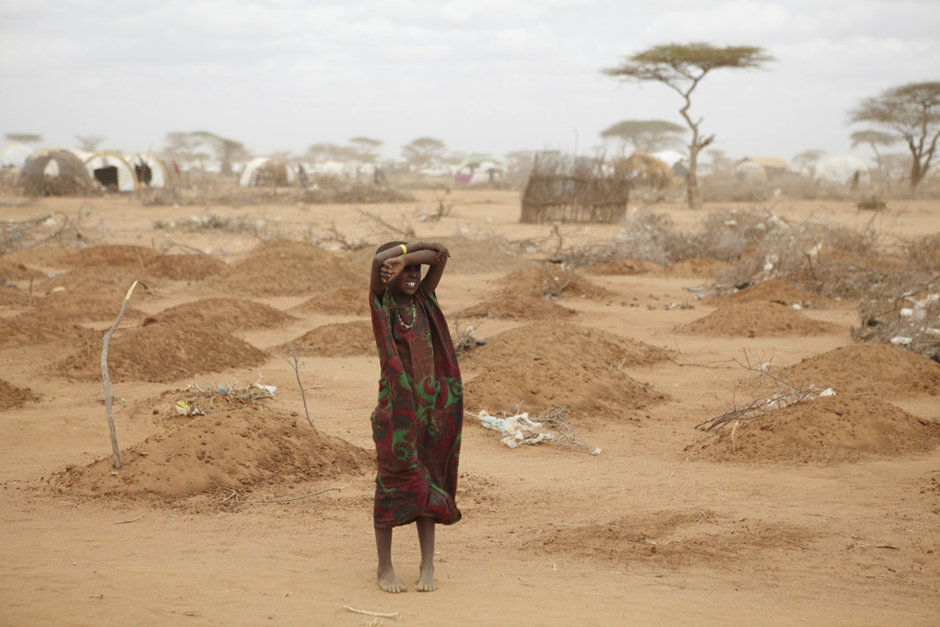The EAPP Master Plan does not include an analysis of the effects of climate change on the regional power strategy or provide any insight into possible problems associated with climate change conditions. The Master Plan mentions Ethiopia’s vulnerability to drought but makes no attempt to address the impacts of possible droughts on the region’s economy (2011b). The Kenyan Post-Disaster Needs Assessment (PDNA) published by the World Bank (2012) indicates significant declines in GDP during droughts. It reports a decline of GDP growth as high as 4% from the 2008-11 drought (World Bank, 2012), shown in Figure 10. This drought affected much of East Africa, including Ethiopia.

Photo: : Mass graves for children in Kenya, 2011 drought. Photo: Oxfam

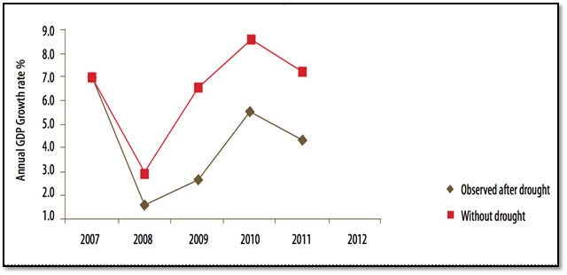

**Figure 10:** *Kenyan GDP Growth With and Without Drought (World Bank, 2012)*

During times of inadequate and seasonally variable generating capacity in Ethiopia or Kenya, the proposed interconnected transmission line is seen as a means of exporting power between the two countries. However, when the entire region is affected, as was the case during the 2011 East African drought, being dependent on hydroelectricity will make it difficult for the region to avoid procuring costly emergency generation units (IFRC, 2011; Karekezi et al, 2012). These units cost up to eight times as much as conventional hydropower (World Bank, 2012, p 112). According to a report by the Energy, Environment and Development Network for Africa (AFREPREN/FWD), the economic losses from the 1999 and 2002 droughts totalled US$442 million. This loss is equivalent to the cost of installing approximately “295 MW of new renewable power capacity” (Karekezi et al, 2012).

**Recommendations**

*The EAPP and its partner states would do well to undertake a full regional evaluation of the system’s risks of climate change to ensure the financial viability of hydropower and sustainable water access in East Africa. The World Bank has, for example, conducted studies of this nature in Latin America, but work in this area is needed across East Africa. We also recommend the EAPP prioritize investments in non-hydro renewables to avoid large losses due to variable generating capacity of hydroelectric units, and to help diversify the energy matrix in the region.*

**Cost Assumptions on Hydropower**

From informal sources we have been told that the EAPP Master Plan estimates a long-term marginal cost of developing Ethiopia’s hydropower potential of 45,000 MW to be $0.04 per kilowatt-hour. The plan assumes a profit margin of $0.01 per kilowatt-hour from exports, which would generate annual net revenue of $263 million. However, this profit margin does not take into account the vulnerability of hydropower production both during droughts and heavy rains, and the financial risks associated with exogenous shocks. A recent report from the University of Oxford suggests that the actual cost of building large dams were “on average 96% higher than the estimated costs,” with three out of four large dams suffering from cost overruns as a result of an overwhelmingly systematic bias towards underestimation (Ansar et al., 2014). Furthermore, the study suggests overruns from forecasting errors are irrespective of the year or decade, thus suggesting a high likelihood of reoccurrence and a continuation of cost and scheduling risks for future dams. In Ethiopia alone, about 15 dams are currently under construction, commission, or discussion in the EAPP’s master plan. Seven of these dams are designed to produce more than 1,000 MW. According to the Oxford study (2014), dams of this size, which typically cost billions of dollars, will likely incur additional billions of dollars in cost overruns. It is reasonable to suggest that with the high probability of cost overruns and the uncertainty of climate change impacts, large dams will financially burden both Ethiopian and EAPP stakeholders.

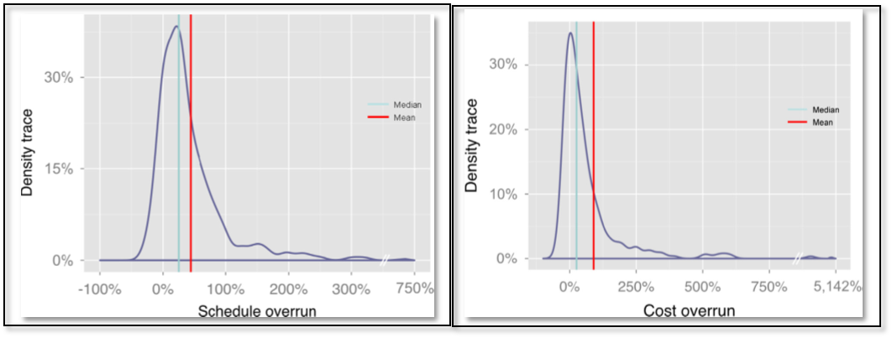

***Figure 11:*** *Big dams run the risk of large upfront costs with cost and schedule overruns (Ansar et al., 2014).*

Due to Ethiopia’s reluctance to encourage private sector investments, these risks will be especially challenging for the Ethiopian government to face. For example, the politically charged construction of the Grand Renaissance dam has resulted in Ethiopia funding a significant portion of the dam by itself. Approximately US$1.5 billion, about a third of the estimated cost to build the dam, has been paid for by the Ethiopian government. Stifling private sector investment due to political concerns restricts economic growth, and Ethiopia has already shown signs of its GDP slowing (most recently, to 9.7% from its previous 11%). In conclusion, Ethiopia’s $263 million annual net revenue from hydropower exports predicted by the EAPP is not guaranteed due to the financial risks associated with large dams. Additionally, risks from the dependence on hydropower in Ethiopia have the potential to affect grid-connected regions such as Kenya (Abiye, 2014).

The EAPP plans to address the East African community’s electricity demand by promoting large grid interconnections in order to import and export power between countries. An example is that greatly expanded hydropower in some areas can impact geothermal energy by reducing available water. This took place in California where the world’s largest geothermal plant, ‘The Geysers,’ saw a reduced generation capacity when water resources were reduced.[[16]](#footnote-16) This potential decline – which need not be the case because the Rift Valley is such an exceptionally large geothermal resource – could occur for operational reasons too. As an example, if power contracts favor hydropower over geothermal, the capacity for geothermal could be idled even if it is the least-cost resource. Other ‘operational problems’ could limit the use of geothermal. In a second hypothetical, Kenya could choose to continue importing power from Ethiopia simply based on existing contracts – something that has happened in Texas where wind was idled due to pre-existing natural gas contracts, or in Germany where coal contracts blocked solar programs. Thankfully, Kenya’s generation expansion plans highlight the importance of geothermal generation for the Kenyan economy, with 70% of its expected installed capacity of 6,000 MW from geothermal power alone. In a further positive step, Kenya began its expansion of geothermal to reduce its dependence on climate-risky hydropower.

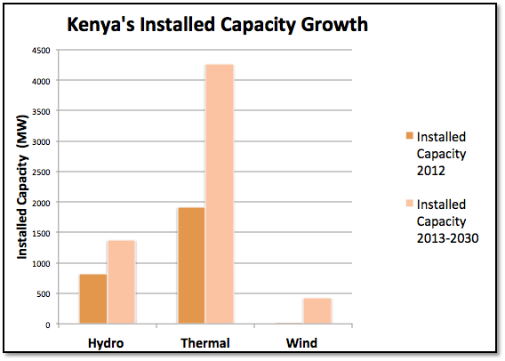

**Figure 12:** *An illustration of how plans can change. Shown here is Kenya’s Current and Future Dependence Forecast Generation as made in 2011 (EAPP, 2011a), leaving out what is now seen to be the leading source of new energy, geothermal power.*

**Alternative Paths for Electrification and Energy Access**

The alleviation of energy poverty may come from various trajectories, not simply the extensive centralized expansion of costly generation projects. Using a decentralized track to electrification, various entities (including nongovernmental organizations, local governments and community energy co-ops, for example) can construct and operate localized mini-grids to deliver electricity to communities not yet connected to national grids. This approach can reduce dependence on hydropower, alleviate climate change risks and increase grid reliability. Off-grid solutions play a crucial role in achieving total energy access by 2030. It requires private investments from international and local entrepreneurs, and dedicated implementation policies and cost effective financial mechanisms (Greacen et al., 2014).

According to IRENA’s *Clean Energy Corridor* report, typical costs are 5-10 cents per kWh and 5-14 cents per kWh for geothermal and wind power respectively (IRENA, 2013a). This makes non-hydropower renewable energy competitive – or cheaper – than fossil fuel electricity generation. Additionally, IRENA reports that the cost of renewable generation for the levelized cost of hydropower generation will stay the same in 2020 with respect to 2012 prices. For hydropower, geothermal and biomass, this analysis puts solar PV and other renewable sources in the competitive range (IRENA, 2013a). Kenya has already taken advantage of this with about 750MW of large scale PV being proposed, including a 20MW solar plant in Nairobi (Willis, 2014).

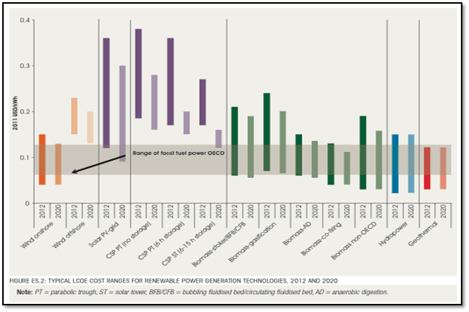

**Figure 13:** *Typical levelized cost per kWh for renewable power generation in year 2012 and 2020 (IRENA, 2013b).*

Typical electricity tariffs in East African communities range from 6 to 17 cents per kilowatt-hour. This makes electricity generated from renewable sources cost-competitive, typically costing 3 to 8 cents for hydro (Uganda however exceeds this: its Bujagali Dam’s tariff is currently 12 cents per kilowatt-hour[[17]](#footnote-17)), 5 to 10 cents for geothermal, and 5 to 14 cents for wind power. With four-fifths of all electricity generated from fossil fuels in the region today – from coal in Southern Africa and oil and gas in East Africa – renewable power can also yield significant reductions in carbon emissions (IRENA, 2013a).

A second issue that dramatically impacts project cost and benefit assessment is the likelihood of cost containment and cost overruns. A recent study (Sovocool, *et al., 2014)* foundthat out of 401 projects only 39 had no overrun, and that wind and solar did have overruns but these were far less in frequency and magnitude than other sources. Further, hydropower is prone to the greatest time overruns and the largest amount of a cost overrun (almost $1 billion per project according to new work from the Global Change Unit at Oxford University). Nuclear is prone to the greatest cost overruns as a percentage of budget (more than 100% across the sample). There are significant methodological questions that come with any such survey, including the importance of absolute or normalized (e.g., per MW) overruns, the degree to which central facility mass production should or should not be separated.

|  |  |  |
| --- | --- | --- |
| **Technology** | **Mean Cost Escalation ($2012)** | **(n) Sample Size** |
| Nuclear reactors | 117 | 180 |
| Hydroelectric dams (large) | 71 | 61 |
| Railway networks | 45 | 58 |
| Bridges and tunnels | 34 | 33 |
| Roads | 20 | 167 |
| Mining | 14 | 63 |
| Thermal Power Plants | 13 | 36 |
| Wind farms | 8 | 35 |
| Transmission Projects | 8 | 50 |
| Solar farms | 1 | 39 |

**Table 3:** *Infrastructure project cost overruns. Source: Sovacool, et al., (2014)*

The region has the capacity to develop both on-grid clean energy corridors and to integrate off-grid energy strategies into the national development plans. The dramatic declines in the costs of solar power (Zhang and Kammen, 2014) illustrate just one clean-energy opportunity that is already a major force in rural energy deployment in the region. The fact that in Kenya off-grid energy services using solar-based lanterns is already the second largest use of mobile payment (MPESA) funds highlights the critical energy-information technology nexus. We recommend a cross-national study of the financial opportunities and barriers that hinder the spread of this model across the region.

This finding ties in to emerging work on off-grid energy services as a key strategy element in meeting energy demands, preventing over-reliance on both fossil-fuels and on hydropower that is likely to become increasingly variable in future years and decades.

While there is broad recognition that lack of access to modern energy has major implications for development, the energy access gap is increasingly being seen as a market. Given the vital role it plays in socioeconomic development, providing improved access to energy has typically been the role of state-owned power utilities, rural energy agencies, international development and nongovernmental organizations, and other public entities. However, with growing recognition of the potential for “base of the pyramid” (BOP) customers to become fast-growing markets for goods and services on the one hand, and the emergence of novel models for serving them on the other, the energy access gap is increasingly being recognized as a commercial opportunity (IFC, 2014).

Integration of technical and financial opportunities to develop and support off-grid energy options should be integrated with the regional potential to build low-carbon, sustainable on-grid options. This strategy to expand both central-station and decentralized energy provides the East African region an exceptional opportunity to continue the development of a job-creating model of a low-carbon energy system that can meet energy demand growth both on-grid and off-grid.

**Summary of Recommendations**

* The EAPP can and should review the various players involved in rural electrification projects across the region in order to establish a plan that incorporates the current and future projects that are already under consideration. This would avoid redundancies and competing efforts and provide a network with which to advance electrification in the most efficient way possible.
* Electricity generated from renewable sources are cost competitive with conventional fossil fuel sources in the region. The governments in the EAPP region can and ideally should actively pursue large-scale grid connected renewable generation as a means of alleviating energy poverty in the region.
* A proper evaluation of the risks of climate change is necessary to ensure the financial viability of hydropower and sustainable water access in East Africa. We recommend the EAPP increase their investment in non-hydro renewables – notably geothermal, solar and wind generation capacity – to avoid large losses due to variable generating capacity of hydroelectric units.
* We also recommend an emphasis on a decentralized approach to electrification using non-hydro renewables, which will increase grid reliability and alleviate the risks of hydropower dependency in a changing climate. This approach requires dedicated policies, private investments and efficient financial mechanisms to tap the market created by the energy access gap. We recommend a cross-national study of the financial opportunities and barriers that hinder the spread of this model across the region.
* Energy efficiency measures and demand side management have the potential to reduce energy demand overall, manage the timing of peaks, which are particularly difficult to address in already stressed energy systems. These options should be actively pursued in the electrified regions of East Africa.

**References**

Abiye, Yonas. (2014). *GDP growth slows down to 9.7 percent*. Retrieved from <http://www.thereporterethiopia.com/index.php/news-headlines/item/1930-gdp-growth-slows-down-to-97-percent>

Aderibigbe, N ( 2014 ). *KenGen, Qatari Firm To Build 500MW Power Plant In Kenya*. Ventures Africa. Retrieved from <http://www.ventures-africa.com/2014/04/kengen-qatari-firm-to-build-500mw-power-plant-in-kenya/>

Alstone, P., Gershenson, D. and Kammen, D. M. (2015) “Decentralized energy systems for clean electricity access“, *Nature Climate Change*, April 15.

Ansar, A., Flyvbjerg, B., Budzier, A., & Lunn, D. (2014). *Should we build more large dams? The actual costs of hydropower megaproject development.* Energy Policy.

Ayieko, Z (2011). *Rural Electrification Programme in Kenya.* AEI Practitioners Worksjop- Dakar, Senegal. Retrieved from <http://siteresources.worldbank.org/EXTAFRREGTOPENERGY/Resources/717305-1327690230600/8397692-1327691237767/Rural_Electrification_in_Kenya_presentation_Final_11thNov2011.pdf>

Block, P., and K. Strzepek (2010). *Economic Analysis of Large-Scale Upstream River Basin Development on the Blue Nile in Ethiopia Considering Transient Conditions, Climate Variability, and Climate Change.* Journal of Water Re- sources Planning and Management136 (2): 156–166.

Davis, M., Lambe, F., Tella, P., & Tessama, Z. (2013). *Mainstreaming Sustainable Energy Access into National Development Planning: the Case of Ethiopia.* Stockholm Environment Institute, Working Paper 2013-09.

Derbew, Dereje (2013). *Ethiopia’s Renewable Energy Power Potential and Development Opportunities.* Ministry of Water and Energy

Diao, X., and A. N. Pratt (2007) “Growth options and poverty reduction in Ethiopia – An economy-wide model analysis.” *Food Policy* 32 (2): 205–228.

East African Power Pool EAPP (2011a). *Final Master Plan Report: Executive Summary “Regional Power System Master Plan and Grid Code Study”*. SNC Lavallin & Parsons Brinckerhoff East African Power Pool EAPP (2011b). *Final Master Plan Report: Volume 1 “Regional Power System Master Plan and Grid Code Study”*. SNC Lavallin & Parsons Brinckerhoff

East African Power Pool EAPP (2011c). *Final Master Plan Report: Appendix B- Part I, ““Regional Power System Master Plan and Grid Code Study”*. SNC Lavallin & Parsons Brinckerhoff.

Eastern Africa Power Pool (2013). *Eastern Africa Power Pool, Addis Ababa, Ethiopia*. Retrieved April 5, 2014, from <http://www.eappool.org> (Updated plan: http://eappool.org/regional-master-plan/)

Emorut, F (2012). *East Africa: Population Growth in EAC Worries UNFPA.* All Africa. Accessed on June 2, 2014. Retrieved from http://allafrica.com/stories/201208120022.html

Energy Private Developers (EPD). *Waste to Power.* Accessed on June 8th, 2014. Retrieved from http://www.epd-rwanda.com/waste-to-power-kigali.html

Ethio Resource Group (2012). *Solar energy vision for Ethiopia: Opportunities for creating a photovoltaic industry in Ethiopia.* International Solar Energy Institute, Stiftung Solarenergie- Solar Energy Foundation, Solar Energy Development Association.

Federation of Universities of Applied Science (FUAS) (2011). *Uganda & Renewable Energy: Country at-a-glance.* Retrieved from http://www.laurea.fi/en/connect/results/Documents/Uganda%20Fact%20Sheet.pdf.

Gathanju, Denis (2010). *Kenya Bets Big On Renewable Energy***.** Renewable Energy World.COM. Retrieved from <http://www.renewableenergyworld.com/rea/news/article/2010/06/kenya-bets-big-on-renewable-energy>.

Gebrehiwot, Z (2013). *EAPP: Execute Strategy Workshop to map out priorities for IRENA’s Africa Clean Energy Corridor Initiative.*

Greacen, C., Knuckles, J., Siyambalapitiya, T., & Tenenbaum, B. (2014). *From the Bottom Up: How Small Power Producers and Mini-Grids Can Deliver Electrification and Renewable Energy in Africa*. : The World Bank. Retrieved from <http://elibrary.worldbank.org/doi/pdf/10.1596/978-1-4648-0093-1>

Hakizimana, G., Osawa, B., Kanigwa, E., Magessa, F., and Mackay, E. (2009). *Renewable Energies in East Africa: Regional Report on Potentials and Markets-5 Country Analyses.* GTZ

Infrastructure Consortium for Africa (2011). *Regional Power Status in African Power Pools*. Retrieved from <http://www.icafrica.org/en/news-events/ica-news/article/ica-report-regional-power-status-in-african-power-pools-3299/>

Integrated Energy Solutions (IES), and Hankins, M. ( 2009). *Tanzania’s Wind Energy Market: Target Market Analysis.* GTZ.

Integrated Energy Solutions (IES), Hankins, M. Saini, A., and Kirai, P. (2009). *Tanzania’s Solar Energy Market: Target Market Analysis.* GTZ.

International Energy Agency (2010). *World Energy Outlook 2010*. Retrieved from http://www.worldenergyoutlook.org/media/weo2010.pdf

International Energy Agency (2011). *The Energy Development Index.* World Energy Outlook. Retrieved from http://www.iea.org/publications/worldenergyoutlook/resources/energydevelopment/theenergydevelopmentindex/

International Federation of Red Cross and Red Crescent Societies (IFRC) (2011). *Drought in the Horn of Africa: Preventing the next disaster*

International Finance Corporation (2014). *From Gap to Opportunity: Business Models for Scaling Up Energy Access.* http://www.ifrc.org

International Renewable Energy Agency (2009). *Africa’s Renewable Future: The Path to Sustainable Growth.* Retrieved from http://www.irena.org/DocumentDownloads/Publications/Africa\_renewable\_future.pdf

International Renewable Energy Agency (2013a). *Africa Clean Energy Corridor Brochure.* Retrieved from http://www.irena.org/DocumentDownloads/Publications/Africa%20Clean%20Energy%20Corridor%20brochure.pdf.

International Renewable Energy Agency (2013b). *Renewable Power Generation Costs in 2012: An Overview.* Retrieved from https://www.irena.org/menu/index.aspx?mnu=Subcat&PriMenuID=36&CatID=141&SubcatID=277

Kambanda, C (2013). *Power Trade in Africa and the Role of Power Pools*. African Development Bank Group: Blogs. Retrieved from http://www.afdb.org/en/blogs/integrating-africa/post/power-trade-in-africa-and-the-role-of-power-pools-12101/

Karekezi, S., Kithyoma, W., Wangeci, J., Gashie, W., Turyahabwe, E., Onguru, O., Balla, P. and Ochieng, X. (2006). *The Potential of Small and Medium-Scale Renewables in Poverty Reduction in Africa*. Nairobi, AFREPREN/FWD and Heinrich Boll Foundation (HBF)

Karekezi, S. and Kithyoma, W. (eds) (2005). Sustainable Energy in Africa: Cogeneration and Geothermal in the East and Horn of Africa – Status and Prospects, Nairobi, AFREPREN/FWD and Heinrich Boll Foundation (HBF)

Karekezi, S., and Kimani, J. (2008). *Renewable Energy Technology Transfer in Africa: The Value of Demonstration.* AFREPREN/FWD.

Karekezi, S., Kimani, J., Onguru, O., Kithyoma, W. (2012). *Large Scale Hydropower, Renewable Energy and Adaption to Climate Change: Climate Change and Energy Security in East and Horn of Africa.* Energy, Environment and Development Network for Africa. Occasional Paper, No. 33.

Koigo, B. (8 June, 2012). *Wind energy development booming in Kenya.* New Agriculturist. Accessed on June 8th, 2014. Retrieved from http://www.newag.info/en/developments/devItem.php?a=2527

Loucif, S., and Rubin, D. (2010) U.S.-Sub-Saharan Africa Trade Profile 2010. International Trade Administration. U.S. Department of Commerce.

Maasho, Aaron. (2014, April 23). *Paying for giant Nile dam itself, Ethiopia thwarts Egypt but takes risks*. Retrieved from http://www.bdlive.co.za/africa/africannews/2014/04/23/paying-for-giant-nile-dam-itself-ethiopia-thwarts-egypt-but-takes-risks

Macpherson, W (2014, January 16). *Ethiopia Announces ambitious power generation expansion programme.* African Energy: Issue 269. *Accessed on June 5th, 2014.*Retrieved from http://archive.crossborderinformation.com/Article/Ethiopia+announces+ambitious+power+generation+expansion+programme.aspx?date=20140116#

McKinsey Global Institute (2012). *Africa at work: Job creation and inclusive growth* <http://www.mckinsey.com/insights/africa/africa_at_work>

Ministry of Energy and Petroleum (2014) *Speech - 5th East Africa, Oil, Gas and Energy Conference - by Hon. Davis Chirchir, Cabinet Secretary – Ministry of Energy & Petroleum*. Retrieved from <http://www.energy.go.ke/index.php/news>

Mohamed, Y.A.; Loulseged, M. 2008. *The Nile Basin Water Resources: Overview of key research questions pertinent to the Nile Basin Initiative*. Colombo, Sri Lanka: International Water Management Institute. 34p. (IWMI Working Paper 127)

NORPLAN (2013). *Forward Looking Review of the Regional Strategy on Scaling Up Access to Modern Energy Services in the East African Community.* Retrieved from http://www.cmi.no/publications/file/4866-forward-looking-review-of-the-regional-strategy-on.pdf

Oduor, J. (2010). *Eastern African Power Pool Presentation to AFSEC: Standardization needs for Integration of Power Pools of Africa.* EAPP

Oduor, J (2012). *High-Level African Dialogue on the Water-Food-Energy Nexus: Power and Water.* Waster African Power Pool.

Power, M., Shanko, M., Hankins, M., Saini, A., Kirai, P. (2009). *Target Market Analysis: Ethiopia’s Solar Energy Market.* Project Development Programme (East Africa). GTZ

Republic of Kenya Ministry of Energy (2012). *National Energy Policy.* Retrieved from <http://webcache.googleusercontent.com/search?q=cache:Obm__4e3vUJ:www.energy.go.ke/index.php/events/finish/3-ministerial-documents/6-national-energy-policy-third-draft-may-11-2012+&cd=1&hl=en&ct=clnk&gl=us>

Robinson, S., Strzepek, K. and Raffaello Cervigni(2013) The Cost of Adapting to Climate Change in Ethiopia: Sector-Wise and Macro-Economic Estimates (International Food Policy Research Institute / Ethiopian Research Development Institute), ESSP Research Paper No. 53.

Sanchez, Daniel L., Nelson, James H., Johnston, J., Mileva, A., and Daniel M. Kammen(2015) “Biomass Enables the Transition to a Carbon-negative Power System Across Western North America”, *Nature Climate Change*, in press. DOI: 10.1038/NCLIMATE2488

Seo, S.N., and R. Mendelsohn (2006). *The Impact of Climate Change on Livestock Management in Africa: A Structural Ricardian Analysis.* CEEPA Discussion Paper 23. Pretoria, South Africa: Center for Environmental Economics and Policy in Africa (CEEPA), University of Pretoria.

Sovacool, B. K., Nugent, D. and Gilbert, A. (2014) “Construction Cost Overruns and Electricity Infrastructure: An Unavoidable Risk?”, *The Electricity Journal*, in press.

U.S. Department of State (2013). *2013 Investment Climate Statement – Ethiopia*. Bureau of Economic and Business Affairs.

Willis, B. (2014, March 5). Kenya's FiT-approved solar pipeline reaches 750MW. *Kenya’s FiT-approved solar pipeline reaches 750MW*. Retrieved June 7, 2014, from http://www.pv-tech.org/news/kenyas\_fit\_approved\_solar\_pipeline\_reaches\_750mw

World Bank (2011) *Rural Energy Electrification Plan for Kenya.* Retrieved from [http://siteresources.worldbank.org/EXTAFRREGTOPENERGY/Resources/717305-1327690230600/83976921327691237767/Rural\_Electrification\_in\_Kenya\_presentation\_Final\_11thNov2011.pdf](http://siteresources.worldbank.org/EXTAFRREGTOPENERGY/Resources/717305-1327690230600/8397692-1327691237767/Rural_Electrification_in_Kenya_presentation_Final_11thNov2011.pdf)

World Bank (2012). *Kenya Post-Disaster Needs Assessment (PDNA) 2008-2011 Drought.* Retrieved from http://www.alnap.org/resource/7622

World Bank (2013). *World Bank Support to NEPAD Planning and Coordinating Authority (NPCA)*. Retrieved from http://www.un.org/africa/osaa/2013\_un\_system/WorldBank.pdf.

Zheng, Cheng and Kammen, Daniel (2014) “An Innovation-Focused Roadmap for a Sustainable Global Photovoltaic Industry,” *Energy Policy,* **67**, 159–169.

**Additional Public Resources**

* <http://www.sciencedaily.com/releases/2011/01/110128113426.htm>http://www.sciencedaily.com/releases/2011/01/110128113426.htm
* <http://pubs.usgs.gov/fs/2012/3053/FS12-3053_ethiopia.pdf>
* http://pubs.usgs.gov/fs/2012/3053/FS12-3053\_ethiopia.pdf
* <http://www.globalwaterforum.org/2012/11/27/the-implications-of-climate-change-for-water-resource-development-in-the-blue-nile-river/>http://www.globalwaterforum.org/2012/11/27/the-implications-of-climate-change-for-water-resource-development-in-the-blue-nile-river/
* http://www.esmap.org/sites/esmap.org/files/ESMAP\_From%20the%20Bottom%20Up\_Optimizedpdf.pdf

**Dr. Daniel M. Kammen** is the Class of 1935 Distinguished Professor of Energy at the University of California, Berkeley, with parallel appointments in the Energy and Resources Group, the Goldman School of Public Policy, and the department of Nuclear Engineering. He was appointed by then Secretary of State Hilary Clinton in 2010 as the first energy fellow of the new Environment and Climate Partnership for the Americas (ECPA) initiative. Kammen is the founding director of the Renewable and Appropriate Energy Laboratory (http://rael.berkeley.edu), and Director of the Transportation Sustainability Research Center. He has served the State of California and US federal government in expert and advisory capacities.

Dr. Kammen was educated in physics at Cornell and Harvard. He was an Assistant Professor and Chair of the Science, Technology and Environmental Policy Program at the Woodrow Wilson School at Princeton University before moving to the University of California, Berkeley. Dr. Kammen has served as a contributing or coordinating lead author on various reports of the Intergovernmental Panel on Climate Change since 1999.

During 2010-2011 Kammen served as the World Bank Group’s first Chief Technical Specialist for Renewable Energy and Energy Efficiency. Kammen’s work at the World Bank included funding electrified personal and municipal vehicles in China, and the $1.24 billion transmission project linking renewable energy assets in Kenya and Ethiopia.

He has authored or co-authored 12 books, written more than 300 peer-reviewed journal publications, has testified more than 40 times to U.S. state and federal congressional briefings, and has provided various governments with more than 50 technical reports.

1. The information given in table 1 is provided Oduor (2010, 2012), and a World Bank report (2013). [↑](#footnote-ref-1)
2. According to a World Bank Report (World Bank, 2013), the WB provided 684 US$ for the Ethiopia-Kenya interconnector and 360 US$ for the Rusumo falls project. [↑](#footnote-ref-2)
3. These figures come from the EAPP Master Plan (2011b), and can be found in tables 4-2: 4-12 (p. 95-110). [↑](#footnote-ref-3)
4. <http://www.standardmedia.co.ke/business/article/2000123800/kenya-among-top-renewable-energy-investors> [↑](#footnote-ref-4)
5. Power generation and consumption for the given East African countries was taken from the ICA’s *Regional Power Status in African Power Pools Report* and sourced from the EAPP Master Plan (ICA, 2011). [↑](#footnote-ref-5)
6. The identified biomass potential in this table comes from Bagasse-Based Cogeneration (from sugar-cane). [↑](#footnote-ref-6)
7. This table was comprised of information from the following sources: FUAS, 2011; Koigo, B., 8 June, 2012; Hakizimana et al, 2009; IES and Hankins, M., 2009; IES et al, 2009, Karekezi, S., and Kimani, J., 2008. [↑](#footnote-ref-7)
8. The EDI is a measurement tool created by the IEA in order to understand the role energy has on the Human Development Index. According to the IEA, the EDI “tracks energy development country-by-country, distinguishing between developments at the household level and at the community level”. The 80 countries included in the IEA’s assessment were based on those with available data. Source: World Energy Outlook, 2012. [↑](#footnote-ref-8)
9. Information on SunnyMoney and M-KOPA Solar can be found at http://sunnymoney.org, http://www.m-kopa.com and http://www.safaricom.co.ke/personal/m-pesa/m-pesa-services-tariffs [↑](#footnote-ref-9)
10. The Model I Scenario is based on an econometric model developed in 2003 and consists of three sub-forecasts: interconnected system forecast, self-constrained forecast, and rural electrification forecast. The EAPP Master Plan states that the model “presents the relationships between electricity demand growth, electricity price in each tariff category and the level of economic activity” (EAPP, 2011c, E-7). [↑](#footnote-ref-10)
11. These projections are consistent with the Africa Economic Outlook report (2013). [↑](#footnote-ref-11)
12. Renewable refers to hydro, wind and solar generation sources; clean refers to natural gas and geothermal; conventional refers to diesel, heavy crude oil, and coal (EAPP, 2011b). [↑](#footnote-ref-12)
13. http://www.iiec.org/index.php/component/docman/doc\_download/31-institutionalizing-energy-efficiency-experiences-from-kenya-and-east-africa-region.html?Itemid= [↑](#footnote-ref-13)
14. “A Climate Trend Analysis of Ethiopia,” USGS/USAID,

    http://www.usaid.gov/sites/default/files/documents/1860/A%20Climate%20Trend%20Analysis%20of%20Ethiopia.pdf [↑](#footnote-ref-14)
15. See for example: “The Water Resource Implications of a Changing Climate in the Volta River Basin” (McCartney et al, <http://www.iwmi.cgiar.org/Publications/IWMI_Research_Reports/PDF/PUB146/RR146.pdf>) and “A Risky Climate for Southern African Hydro,” Beilfuss, http://www.internationalrivers.org/resources/a-risky-climate-for-southern-african-hydro-7673 [↑](#footnote-ref-15)
16. https://pangea.stanford.edu/ERE/pdf/IGAstandard/SGW/2011/sanyal3.pdf [↑](#footnote-ref-16)
17. See http://www.independent.co.ug/cover-story/5390-why-is-bujagali-power-expensive [↑](#footnote-ref-17)